Colossal Hospitality Website Discovery

Brand & Positioning

Q) How would you describe Colossal Hospitality in 3–5 words?
Ans) Premium | Experiential |Contemporary | Visionary | Lifestyle-Led

Q) Should the parent brand feel more corporate or culture/lifestyle-led?
Ans) The parent brand should balance corporate credibility with a strong lifestyle identity. It should feel premium, design forward and experience-led while maintaining the trust and professionalism of a hospitality group.

Q) Is the focus on the group or individual brands?
Ans) The website should establish Colossal Hospitality as the parent company while showcasing each individual brand as part of its growing portfolio.

Brand Architecture

Q) How many brands/outlets fall under Colossal?
Ans) Colossal Hospitality currently operates a portfolio of hospitality and entertainment brands, with plans to continue expanding across new concepts and markets.
Please share the logos of all brands under Colossal.
Current brands include:
- Epitome Mumbai
- Epitome Pune
- Kynd Café & Bar Pune
- Epitome Live
- Naia (upcoming)
- Khufè (upcoming)

Q) Should all brands feel visually unified or retain distinct identities?
Ans) Each brand should retain its own unique identity while being presented under a unified premium design language that reflects the Colossal ecosystem.

Website Objective

Q) What is the primary goal of the website?
Ans) The primary objective is to establish Colossal Hospitality as a leading hospitality and entertainment group, showcase its portfolio of brands, communicate its vision and scale, build credibility with customers, investors, partners, and talent, and serve as the gateway to each individual brand.

Q) What is the one key action a user should take?
Ans) Visitors should explore the Colossal Hospitality portfolio, understand the group’s vision and scale, and seamlessly navigate to the individual brand websites to learn more, make reservations, or engage with each concept.

Target Audience

Q) Who are we speaking to primarily?
- Customers & Guests
- Investors
- Banquet Parties
- Media & Press
- Hospitality Professionals & Future Talent
- Brand Collaborators & Creators
- Event Planners & Corporate Clients

Q) Audience Profile
- Age: 21 - 45
- Urban professionals
- Entrepreneurs
- Luxury and lifestyle consumers
- High disposable income
- Interested in premium dining, nightlife, travel, and experiences

Design & Visual Direction
Q) Preferred aesthetic
Ans) Editorial Luxury with Architectural Minimalism and Quiet Luxury.

Q) Do you have a defined colour palette?
Ans) We’d like to explore two visual directions for the parent brand one with a lighter aesthetic and one with a darker aesthetic. Please share colour palette options that best represent Colossal Hospitality for both directions. The parent brand should maintain a timeless, neutral luxury identity, while each individual brand retains its own distinct visual identity.
I’m attaching a colour palette that reflects the direction I have in mind for the parent brand. It’s only a reference, and I’m open to your suggestions and refinements.
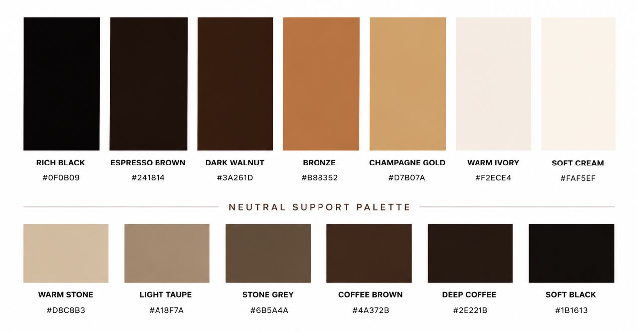

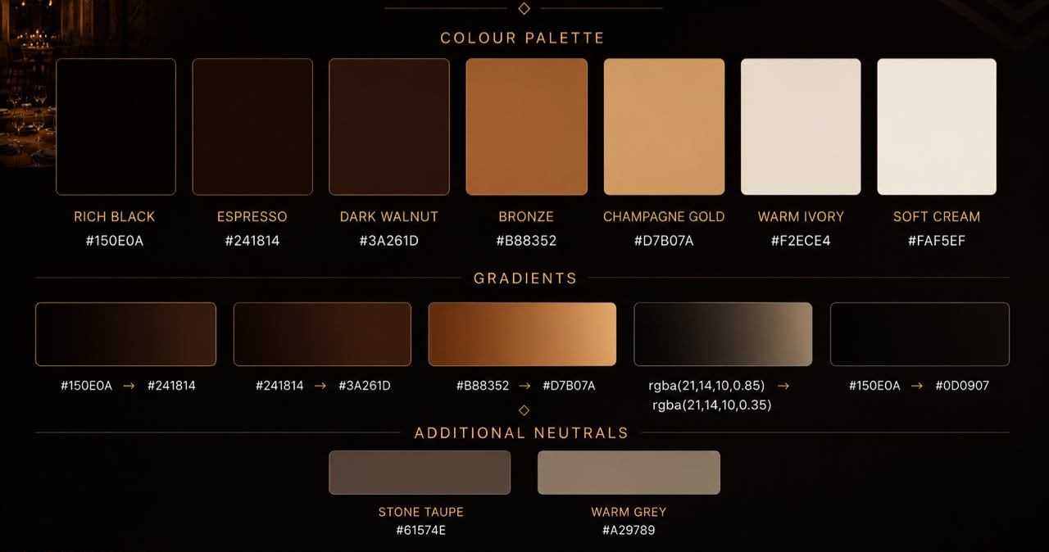

Q) Website references
- Tao Group Hospitality - https://taogroup.com
- Aman - https://www.aman.com
- Sexy Fish - https://sexyfish.com
- Zuma - https://www.zumarestaurant.com
- Amazónico - https://www.amazonicorestaurant.com
- Bastian Hospitality - https://www.bastianhospitality.com
- Addmind Hospitality - https://addmind.com
- Fundamental Hospitality - https://fundamentalhospitality.com
- Solutions Leisure Group - https://solutions-leisure.com
- CÉ LA VI Dubai - https://dxb.celavi.com
- Dream Dubai - https://dreamdxb.com

Q) References to avoid
Ans) Overly corporate websites, cluttered layouts, generic templates, excessive animations, or stock-heavy visuals.

Content & Assets

Q) Do you have high-quality images/videos for all brands?
Ans) Yes, although additional curated photography and videography may be developed to ensure a consistent premium presentation.

Q) Would you be open to a fresh shoot for consistency?
Ans) Yes. A dedicated lifestyle and architectural shoot would help unify the visual storytelling across all brands.

Structure & Experience

Q) Should each brand have a detailed page or just a preview section?
Ans) Each brand should have a premium preview section featuring its story, imagery, and identity. Clicking on the brand should redirect users to its dedicated website for the complete brand experience.

Q) Please share links of existing brand websites/pages that need to be included.
Ans) To be provided

Q) Should users stay on this site or be redirected to individual brand pages?
Ans) Users should discover the portfolio on the Colossal website and then be redirected to the respective brand websites for reservations, menus, events, and detailed information.

Features
The website should include:
Website Sections
- Home
- About Us
- Our Brands
- Company Snapshot
- Experiences
- Events
- Reservations
- Users first see all Colossal Hospitality outlets.
- Selecting an outlet redirects them to the respective reservation channel (WhatsApp, Call, or the outlet’s booking platform).
- Banquets & Private Events
- Special Menus
- Press / Media
- Awards & Recognitions
- Careers
- Contact
- Social Media
Additional Website Features
- Mobile-First Responsive Experience
- The website should be designed with a mobile-first approach, ensuring a seamless, premium, and fully responsive experience across mobile, tablet, and desktop devices.
- Fast Loading & Optimized Performance
- Smooth Scroll & Premium Micro-interactions
- SEO-Friendly Structure
- Easy-to-Manage CMS (Content Management System) for updating content, events, menus, and brand information
- Integrated Google Maps for all outlets
- Inquiry & Contact Forms
- WhatsApp Integration
- High-Quality Image & Video Galleries
- Brand-specific Redirection
- Users can seamlessly navigate from the Colossal Hospitality website to the dedicated website of each individual brand.
Overall Creative Direction

The website should be visually led, with a strong opening statement that establishes the Colossal Hospitality brand. As users navigate through the website, they should seamlessly discover our brands, experiences, and key offerings. The overall journey should feel immersive, intuitive, and premium, allowing users to explore the brand naturally through the website.

